Preliminary Security Assessment
(Cebu MD Office @ Keppel Business Center)
Department: Global Information Security
Document Name: | Preliminary Security Assessment  (Cebu MD Office @ Keppel Business Center)
Domain: | Global Information Security
Document Owner: | Ed Williams : Information Security Analyst  enwilliams@eliglobal.com
Document Approver:
Version #: | 1.0 (First Draft - 18 MAR 2014)

Revision History
The Revision History table below provides a record of all revisions made to this document throughout its life cycle. Updates are tracked by date the revisions were made, the version number, a brief description of the changes made and reason, as well as the name of the reviser and the approver.

Effective Date | Version # | Change Description/ Reason | Created/Revised by | Approved by
03-18-2016 | 1.0 | First copy of this document | Ed Williams

Disclaimer
This document is Copyright © 2015 by the Eli Global. It may be freely redistributed in its entirety provided that this copyright notice is not removed. It may not be sold for profit or used in commercial documents without the written permission of the copyright holder. This document is provided “as is” without any express or implied warranty. This document is for educational purposes only and does not constitute legal advice. If you require legal advice, you should consult with an attorney.

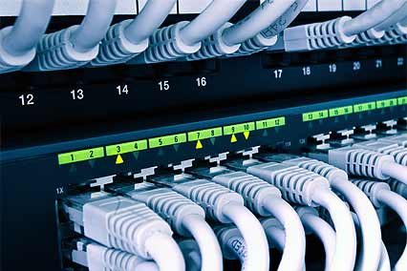
2016
>!< Eli Global Ed Williams | Information Security Analyst enwilliams@eliglobal.com
3/18/2016

Preliminary Security Assessment (CEBU-MD Office @ Keppel Business Center)

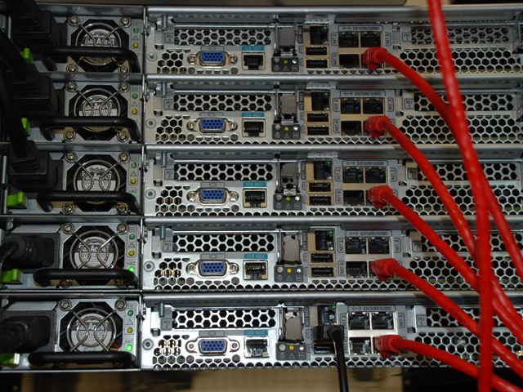

Forward

This preliminary initial security assessment entails notes compiled from an onsite analysis with respect to observations on current utilization of hardware /software by Developers for the MD Office Cebu branch of operations within Eli Global.

This assessment will outline observed “shortcomings” for the existing network typology, as well as those shortcomings that are rooted in the current human processes and operating methodologies.
This preliminary assessment will attempt to provide acceptable secure Information Technology solutions to said observed security shortcomings.

This assessment is created in a category based outline format.
This preliminary assessment will outline all observed networking, systems, human resource computer interactions, and hardware and software security related shortcomings

Areas of Assessment

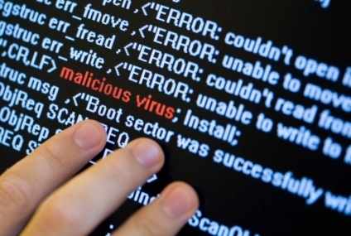
- Physical Security
- Network Hardware Backups & Essential Servers
- Local Network Infrastructure Monitoring
- Local Network Infrastructure Documentation
- Per Campaign Observations and Initial Assessments
- Synopsis

- Physical Security Assessment and Observations

Observed Risk | Recommended Remediation
Currently there is no CCTV monitoring for the main MD Office Operations Area. MD Office currently relies on the Keppel Building Officials to provide CCTV recordings (outside MD Office only). MD Office has no knowledge of the quality of CCT V recordings, duration of recording or retention standards. | Ideally MD Office should have their own internal CCTV. The internal CCTV should be IP Based, to allow expedient retrieval and remote viewing. The CCTV system should have its own APC-UPS independent from the building supplied power (for continued operation during electrical brown outs). MD Office CCTV should have a minimum retention of 30 days recording time.
Observed Risk (per Upendra) | . Recommended Remediation (per Upendra)
Currently MD Office has no Primary Domain Controller or Backup Domain Controller | A recommendation was made to setup a PDC and BDC for centralized user profile management.

- Physical Security Assessment and Observations (continued)

Observed Risk (per Upendra) | Recommended Remediation (per Upendra)

Currently networking equipment sits on a Baking Rack like bread! The equipment is open and exposed with no physical protection from dust, human malevolent interference or the open elements. | There is currently an Equipment Rack in the JY Cebu Operations Office not being utilized. The possibility exist that this rack can be sold between business units to mitigate this shortcoming at MD Office.
Observed Risk | Recommended Remediation
Currently MD Office has “legacy” old network switches. These switches are un-manageable. The current switch typology is well beyond its acceptable life cycle. | Prior recommendations have been made to upgrade MD Office switches to Cisco SG-300. Procurement of said Cisco SG-300 switches is crucial at the point in time.

- Essential Equipment, Servers & Backups

Observed Risk | Recommended Remediation
Currently there are no network equipment IOS backups onsite. In the event that the main internal routing device fails; all MD Office internet activity will cease. | Create an Inter-Network Equipment Operating system (IOS) Backup server and repository Server. (or use an existing server). Permissions for this IOS repository will be set for Domain Admin and Enterprise Admin only.

Legacy Network Cabling: MD Office has inherited an old network cable infrastructure from the previous office occupants. The cable is Category 5 (mid-1990 to 2000). The cable only supports 10/100 Mbps connectivity. | Implement Category 6e cable at MD Office. Increase data throughput up to 1000 Mpbs. Cat 6e will allow faster Voice, Video and Data to each Workstation.
There does not appear to be any form of Encrypted Backup Policy in place to securely archive programming code. Per HIPAA regulations all programming code, medical information or PII (Personal Indentifying Information ) should be archived in an Encrypted format (minimum AES-256) | A primary and alternate individual will be assigned to Programming Code Backup Operations. Programming and Development code will be archived and stored locally in an Encrypted format (minimum AES-256). Bit Locker can be used to store Programming Code HIPAA compliant format.
Inadequate or non-existent Backup testing to ensure the “integrity of backed-up data” is valid. There is no policy or procedure to provide guidance on testing and /or the verification of backed-up data. | Periodic Backup Testing will ensure Backup Operations are successful. Testing all Backups will confirm the integrity of Backed Up data. Periodic Testing of Backed Up data should be performed monthly (a minimum of one month for periodic testing)
- Essential Equipment, Servers & Backups (continued)
Observed Risk | Recommended Remediation
FIREWALL: Serious Risk - MD Office does not have any type of “Firewall” currently in place. There is no way to monitor incoming or outgoing connections. MD Office does not have the ability to actively monitor internet activity. MD Office has no way to determine if their Programming Code is being Pirated, uploaded to a Cloud Drive or sent to offsite storage. | Immediately implement an active Firewall and Firewall Policy to gain control, monitor and secure internal Programming Code. The fastest and easiest Firewall to implement to gain control in the interim, is to implement PF Sense.
Encrypted Hard Drives: Media inside MD Office is currently non-encrypted. Per HIPAA compliance standards all data pertaining to Medical Programming Code, Patient Data and PII will be stored on Encrypted Media. | Encrypt all Hard Disk inside of workstations utilizing Microsoft Bit Locker. Bit Locker key management will be managed internally or via the IT Department. (or both)
End Point Protection: Currently all workstations within MD Office allow for data transfer via workstation USB Ports. (uploading and downloading via mobile phone, tablets, etc) | Immediately implement “End Point Protection” that provides centralized management. (Procurement and purchasing documentation previously been submitted to solve this problem- but has stalled somewhere in the procurement process?)
WSUS: Currently there are no centralized Patch Management Servers in place for MD Office. No Windows Systems Update Servers, No Anti-Virus definition Servers, etc. | Centralized Patch management would allow MD Office Admin’s to vet any potentially l lethal patches prior to deployment to internal workstations, servers and networking equipment. The ability to protect Programming Code from lethal patches, updates and bug-fixes is critical.


- Local Network Infrastructure Monitoring

Observed Risk | Recommended Remediation
Currently there is no form of software or hardware Asset management in place for MD Office. Hardware and Software accountability are not proactively management by local IT Staff, MD Office or any third party entity. | Active IT Infrastructure monitoring and Asset Tag management would allow Local IT Staff and MD Office Administrators to activity monitor hardware resources (workstations, servers, laptops, etc) . In the event of a missing Hardware, MD Office Admin’s can act accordingly in real time.


- Local Network Infrastructure Documentation

Observed Risk | Recommended Remediation
Non-existent visual network documentation to facilitate hardware troubleshooting, security breach path investigations, hardware interconnections and routing, etc. | Delegation and assignment of the task to “map and illustrate” the current network typology must be executed. Network visual illustrations give IT Administrators the ability to troubleshoot, design and scale the network upwards to facilitate growth. Visual documentation can be in the form of MS-Visio documentation, or paper format.
No documentation for current Server layouts, Virtual Machines, Desktop configurations, Antivirus, Malware protection, etc. ( within MD Office) | All hardware and software should be accompanied by documentation. Said documentation should contain: SLA (Service Level Agreements), Serial Numbers, Model Numbers, Log In details, Software Vendor info, Life Cycle dates, etc. The Hardware and Software Life Cycle documentation can be stored digitally or in Paper format under secure access parameters only.

- Internal Observations and Initial Assessments

Observed Risk | Recommended Remediation
Network Time Protocol Synchronization: Currently there appears as if there is no NTP Server in place. Computers within MD Office may (or may not) have the same time and date setting. Time and date settings appear to be different amongst Servers, Routers, Switches, Wifi, etc. The network time synchronization is non-existent or woefully mis-managed. | Network Time Protocol (NTP) is a networking protocol for clock synchronization between computer systems over packet-switched, variable-latency data networks. This essential network protocol alleviates many illusive problems experienced in today networked world. A local NTP Server can supply clock synchronization for all servers, network equipment, desktops and associated computer equipment.
Currently No Logical Separation exist with respect to VLAN typologies. | VLAN,s would allow proper protection of data and Programming Code within MD Office from outside equipment (ie: cell phones,, tablets, BYOD Devices) A VLAN typology would contain and quarantine all MD Office workstations from Servers and Networking equipment. Implementing a VLAN typology would prevent data leakage and allow better control in a  Programming Code environment

VI. Synopsis

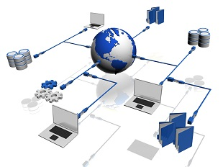
The issues discovered and annotated herein can be mitigated. MD Office has “minor” Security flaws that can be mitigated and resolved in a short expanse of time (less than one month 70% of the issues can be resolved). Issues such an Open Source PF Sense Firewall installation, can be installed by the local Cebu IT Staff in less than 3 days time. A local purchase and installation of CCTV for MD Office can be accomplished in 48 hours!

MD Office has the potential to securely safe guard its Programming Code right now. In the action of doing “nothing” to mitigate the herein annotated security flaws; MD Office Cebu has the potential to be an example of HIPAA Programming Code Data Leakage. The Risk is very real and evident. Now is the time to act accordingly.

>!< Eli Global
: Ed Williams | Information Security Analyst
: +63.9276727069
enwilliams@eliglobal.com
: 2nd Level, JY Square Discovery Mall,
Lahug, Cebu City 6000

